Agenda
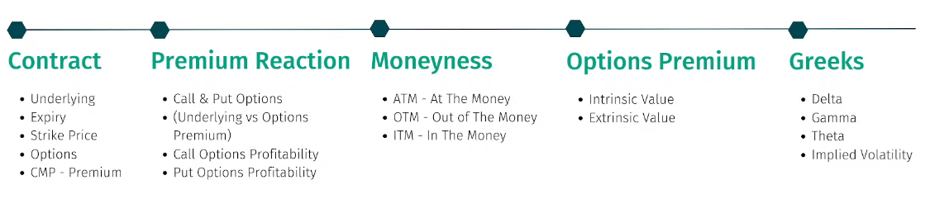
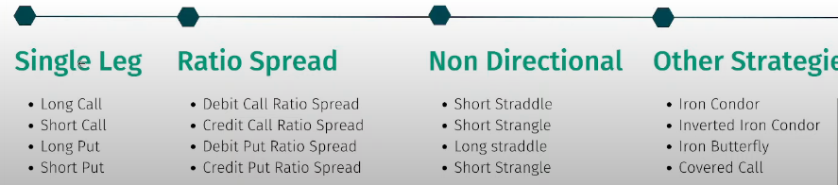

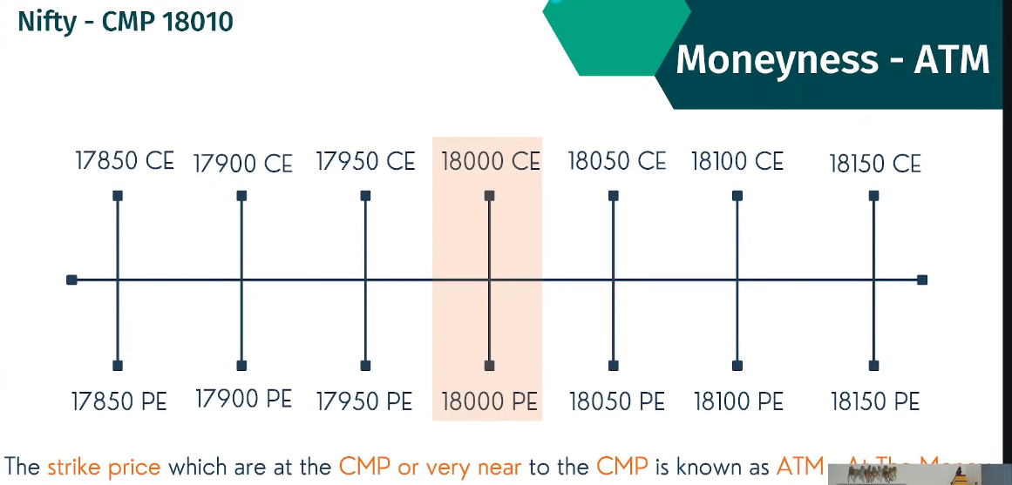
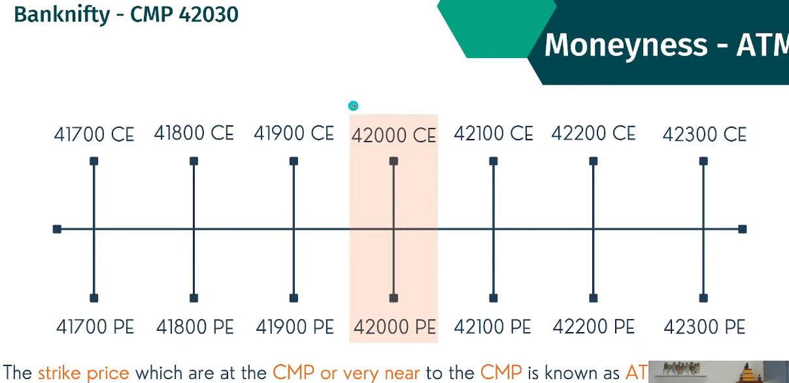

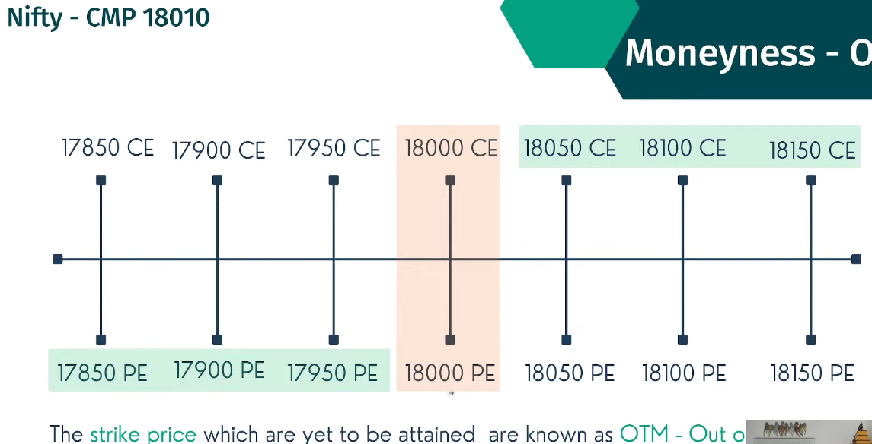

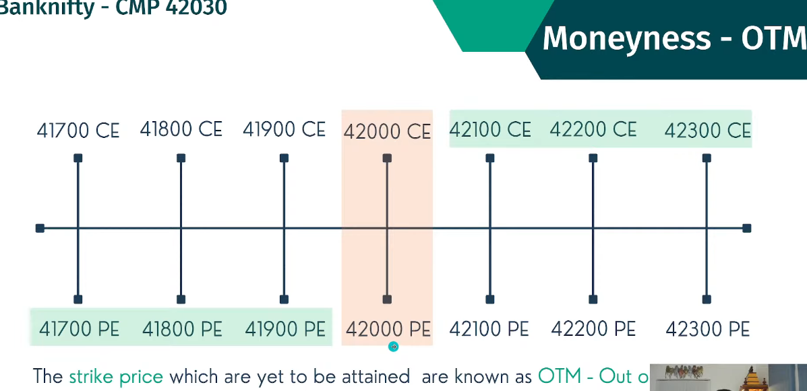

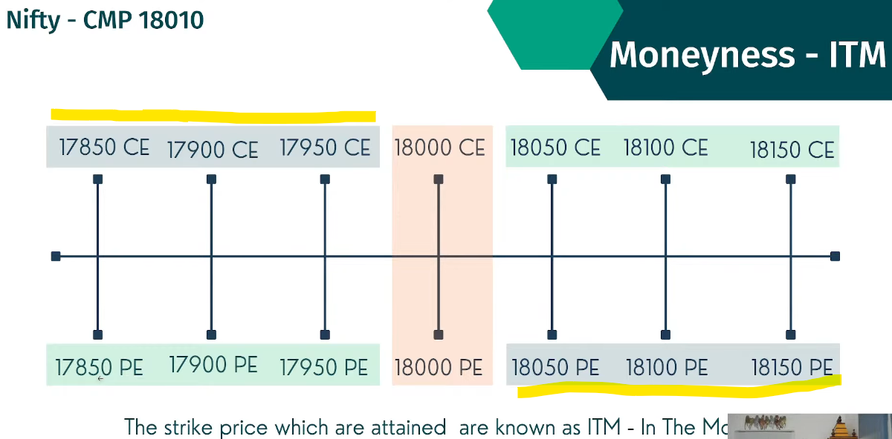

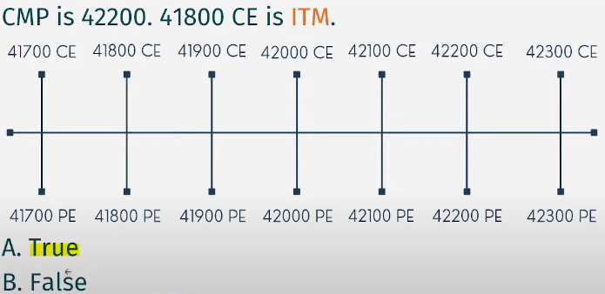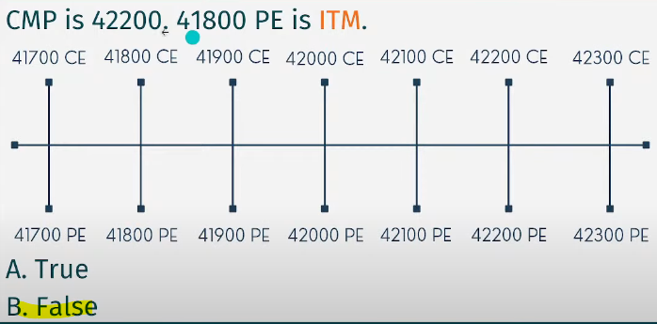
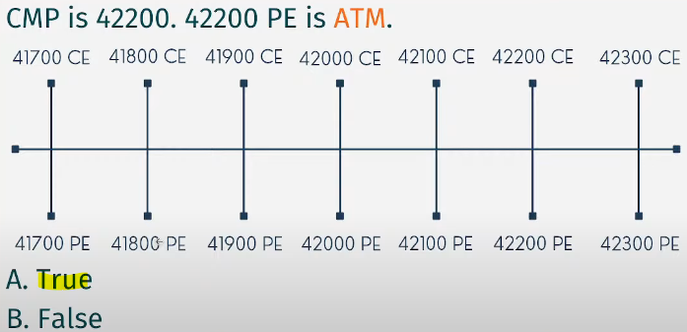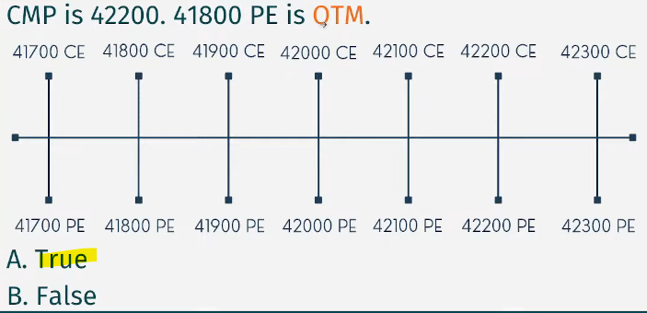
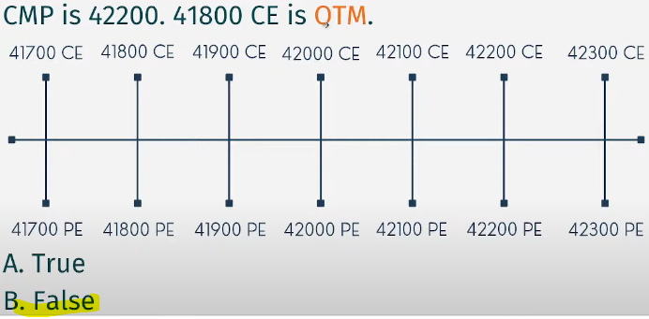
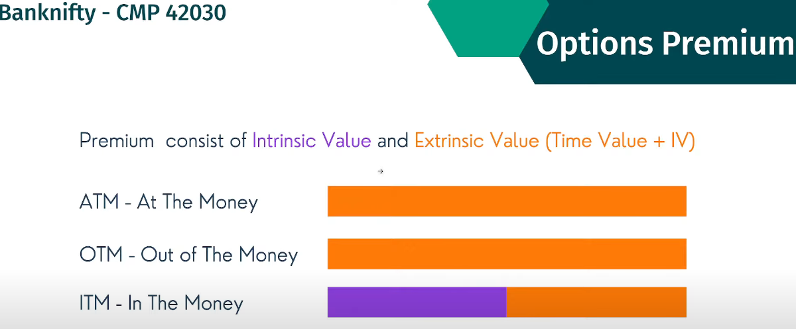

Sometimes even though market went high, but call option may be in loss.

Intrinsic premium – does not dissolve or go low
Extrinsic value – dissolving value
ITM – HAVE BOTH VALUE
ATM & OTM HAVE EXTRINSIC VALUE ONLY

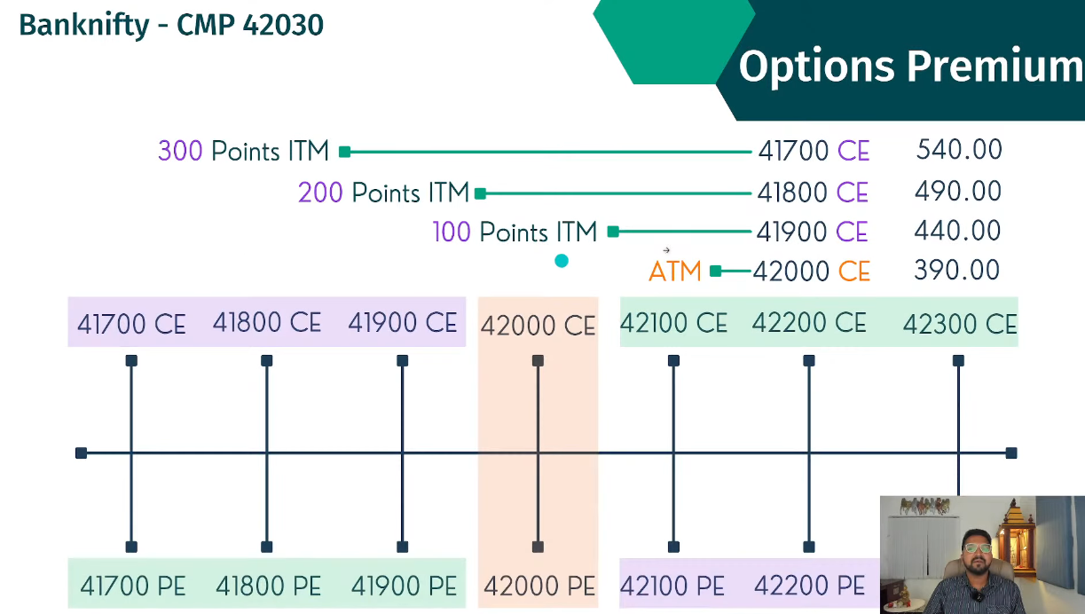

ITM 41900CE – 440 IS PREMIUM, 100 POINTS
Since it is 100 points, actual value is 100 which in intrinsic value and remaining 340 which is extrinsic value

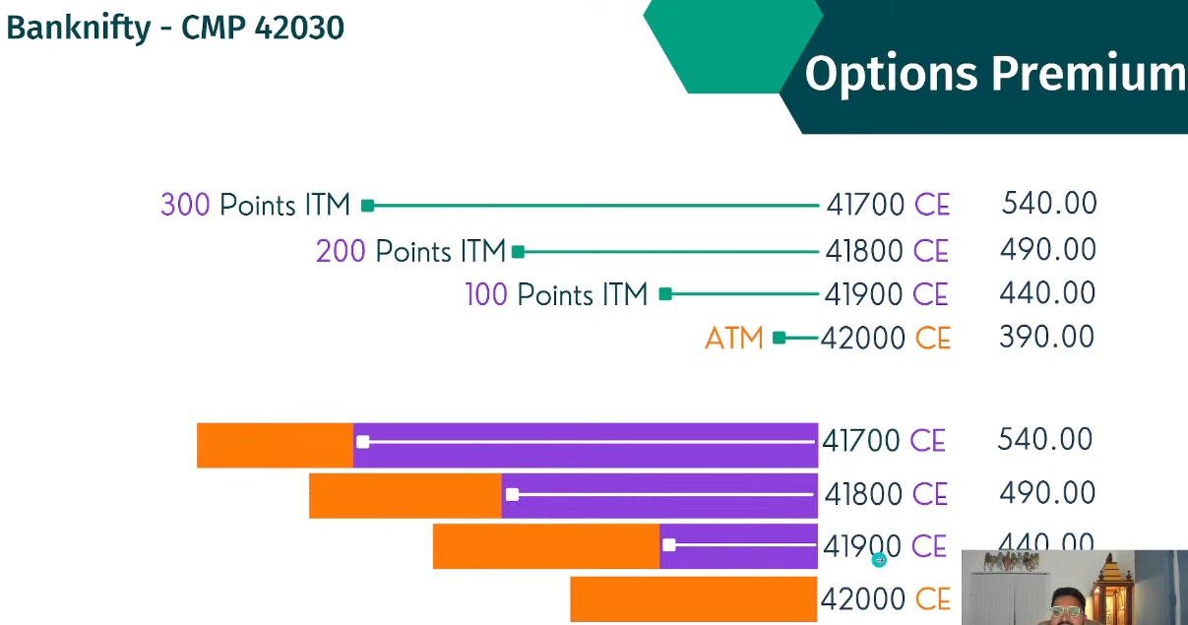

At expiry, Extrinsic value dissolve and goes to zero.

41900 CE – 440 PREIMIUM – 100 POINTS ITM – BEFORE EXPIRY (100 INTRINSIC VALUE AND 340 EXTRINSIC VALUE WHICH DISOLVES DURING EXPIRY)

41900 CE – 100 PREIMIUM – 100 POINTS – AT EXPIRY (340 NULLIFIED AND ONLY INTRINSIC VALUE IS PRESENT ON EXPIRY)

